ICS-344 - Information Security
Section 02
Your DVSA Website URL:
http://dvsa-website-test-546079881937-us-east-1.s3-website.us-east-1.amazonaws.com/
AWS Region:
us-east-1 (N.Virginia)
Date: 3 May 2026
Vulnerability Title(s):
Sensitive Data Exposure – JWT Token Stored in Browser Local Storage
Bonus

Goal and Vulnerability Summary
This task demonstrates a security weakness where the application stores authentication tokens in a way that allows them to be reused outside the original browser session. The goal is to show that a stolen token can be used independently to access protected APIs, leading to unauthorized access to user data.

Why This Works / Root Cause
The application relies solely on the presence of a valid JWT token for authentication. The token is not bound to a specific client or session, and it can be reused without additional verification. This allows an attacker to use the token independently once it is exposed.

Environment and Setup
- DVSA deployed in AWS (us-east-1)
- API Gateway endpoint
- Authentication via AWS Cognito
- Tools used:
- Kali Linux terminal
- curl
- jq

Environment variables:
export API
export TOKEN

Reproduction Steps
- Authenticate normally and obtain a valid JWT token.
- Send a request using the token:
curl -H "authorization: $TOKEN"
- Observe successful retrieval of user orders.
- Remove the token:
unset TOKEN
- Send the request again and observe failure.
- Open a new terminal session and manually paste the token.
- Send the request again using the pasted token.
- Observe that access is still granted without authentication.

Evidence and Proof
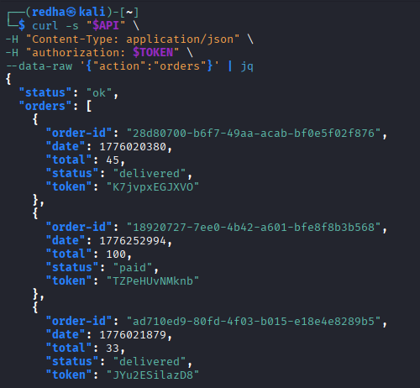
Figure 1:shows normal authenticated access returning user orders.

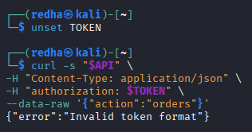
Figure 2: shows that removing the token results in a failed request.

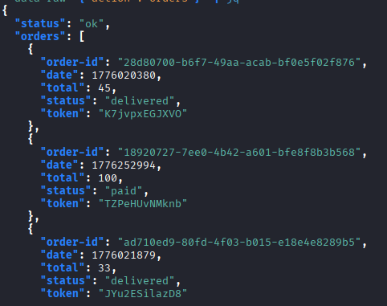
Figure 3: shows that the same token can be reused in a separate session.
These results confirm that the token alone is sufficient to access protected resources.

Fix Strategy / Probable Mitigation
The vulnerability can be mitigated by preventing exposure of authentication tokens. Tokens should not be stored in locations accessible to JavaScript. Instead, secure storage mechanisms such as HttpOnly cookies should be used to prevent unauthorized access.

Code / Config Changes
Vulnerable approach:
localStorage.setItem("token", jwt)

Secure approach:
Set-Cookie: token=<jwt>; HttpOnly; Secure; SameSite=Strict

This change ensures that tokens cannot be accessed or stolen through client-side scripts.

Verification After Fix
After removing the token, requests fail with an authentication error, confirming that access depends on the token. When the token is manually reintroduced, access is restored, confirming that the vulnerability is related to token exposure and reuse.

Structured Operation and Security Analysis

Table 1: Structured analysis summary — Table A
Vulnerability | Intended Rule(s) | Artifacts Used to Infer Rule | Normal Behavior Evi dence | Exploit Behavior Evi dence
Insecure Storage of JWT Tokens in Browser Local Storage | Authentication tokens must not be accessible or reusable outside a secure client session | Terminal output, API responses, curl requests | Valid token allows access to user orders through authenticated requests | Stolen token reused in a separate session successfully retrieves user data

Table 2: Structured analysis summary — Table B:
Vulnerability | Why This Is a Deviation | Deviation Class | Fix Applied  (where) | Post-Fix Verification | Optional Latency Be fore / After Logging
Insecure Storage of JWT Tokens in Browser Local Storage | The token can be reused outside its original session, violating secure session binding principles | Security misuse | Store token in HttpOnly Secure cookies (frontend authentication logic) | Access fails when token is removed and succeeds again when token is reused | N/A

Takeaway / Lessons
This demonstration shows that authentication tokens must be protected against exposure. If a token is accessible and reusable, it can lead to session hijacking and unauthorized access. Secure storage and proper handling of tokens are critical in serverless applications.

